Code Review (Zhongyao Wang)

File reviewed: Game1.cs

Author: Phil, Yifei, Zhongyao

Time to write code review: 40 minutes.

Date: 11/8/2022

Comments: The code works, but probably somethings need to be refactored or updated.

Ps: If you look through this code review, please go from bottom to top, cuz that’s how I analyze each portion of this file.

1, There are too many methods inside game1.cs. Pause game, Debug box, onFlag change… etc.

Specifically, timecount method could write in mario.cs if we make it as a static method. 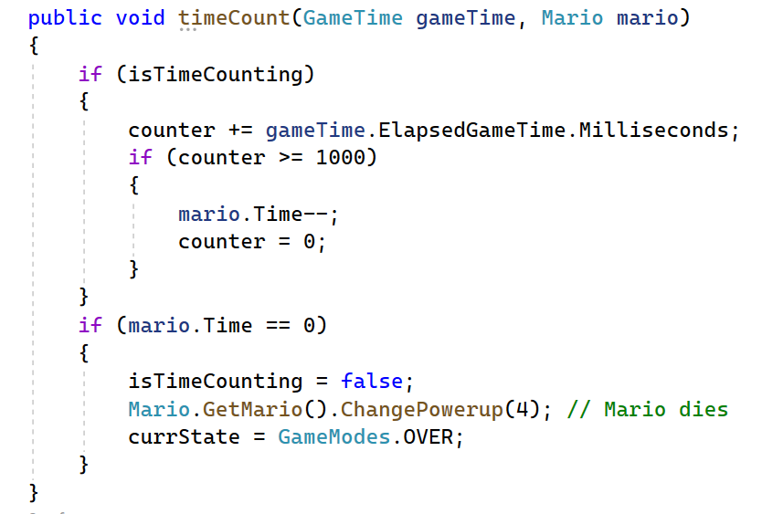

However, if you consider it as global method which somehow does not only focus on one mario. For example, if in future practices, you add multiplayer inside this game, add this method in game1.cs is reasonable in some extents. Also, specifically inside this method, there’re somethings really tricky in case we set a counter here only to add up to a thousand. I understand that since we use milliseconds as unit, so we need 1000 for sure to capture 1 second. However, I am wondering why don’t use something like gametime.ElapsedGameTime.seconds. Is that not a permitted way? I don’t know. Thus, in that case, you could simply write time += ….gametime.seconds. Something like that.

2.

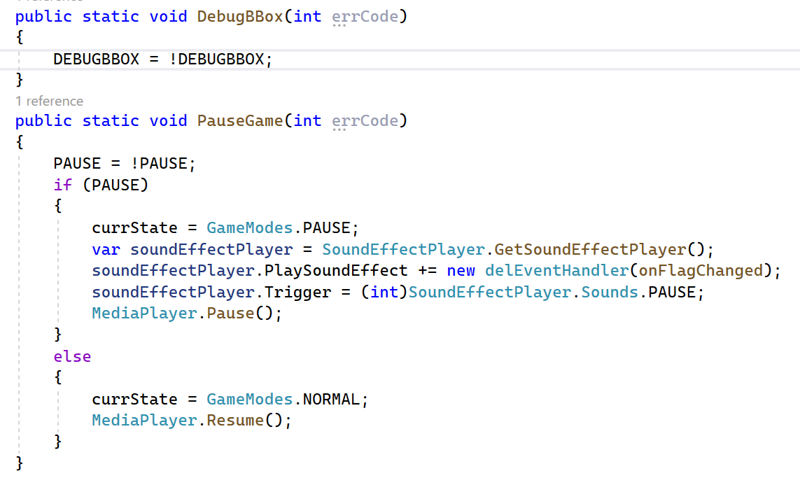

For this two methods, I believe these should be something related to game state. I believe we could also add them inside game state class. Anyways, these two methods are easy to understand. In some cases they are simply a kind of switch to switch from different game state. Also, I am not sure why we need to add sound effects updates in this single method. I mean, it works but why we don’t write it inside update, in case that will be much more understandable.

For the draw method inside game1.cs, it’s long and seems complicated. However, I thinks it’s easy to understand in structure. It’s clear that for different states / background of the game, different draws should be implemented. Names are also clear.

For the update method inside game1.cs. It’s also long and complicated… However, even though the structure is understandable, I believe we should add more update content inside each class, for example mario, block.. Plus, things should be rearranged a little bit. For example, for this camera commands, why added in between tow “giant” if statements. I believe, we should be add it to the beginning of update.

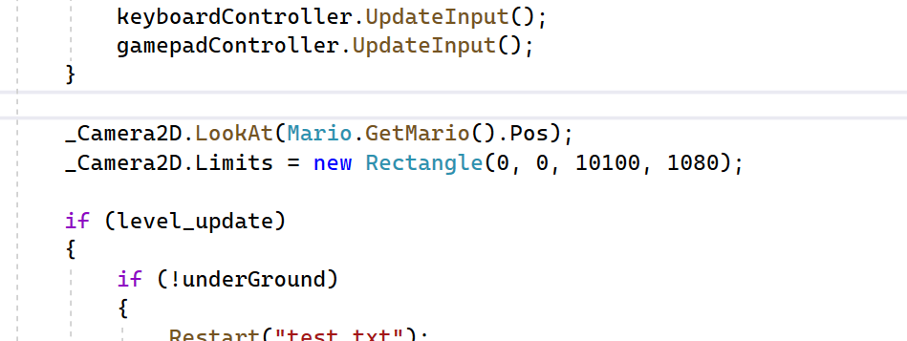

For two restarts methods, they look kinda similar honestly. For the first one it’s when you enter a pipe in case you want to change from world to underground level. And for the second restart is when you press R. Look nice.

For the rest, there are not much that changed.

Zhongyao